Experiment:- 16

Problem Statement:-
In Linux systems, administrators often need to list files along with their metadata such as creation or modification time in an organized and readable format. Displaying file names with serial numbers and timestamps is useful for auditing, reporting, backup verification, and log management. Automating this task using shell scripting improves efficiency and consistency.
The problem is to write a shell script that lists all files in a directory along with a serial number and their creation (or last modification) date, demonstrating file metadata handling and formatted output in Bash scripting.

Aim:-Shell script to print file names with creation date and serial number

Procedure:-
A. Writing the Shell Script
1. Open the terminal.
2. Create a script file: nano file_info.sh

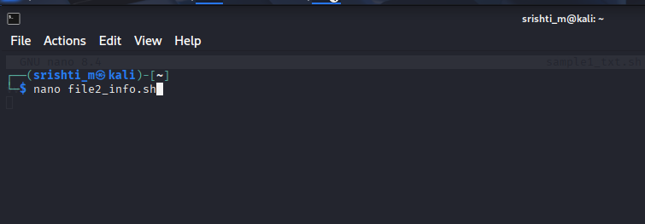

3. Enter the following script:
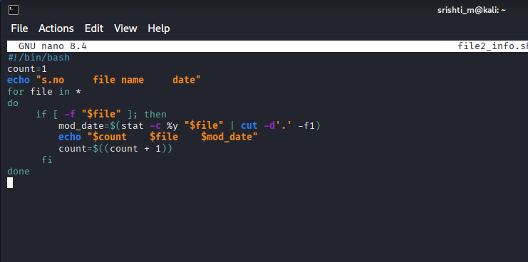

4. Save and exit the editor.
5. Make the script executable: chmod +x file_info.sh

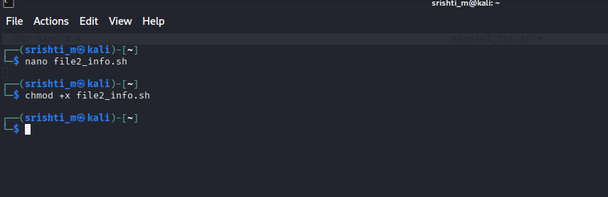

6. Run the script in a directory containing files: ./file_info.sh
